

**INSTITUCIÓN EDUCATIVA**

**NOMBRE DE LA I.E AQUÍ**

**ÁREA DE COMUNICACIÓN**

**DOCENTE : Juan Santos Bonifaz**

**GRADOS : 1° - 2°**

**SECCIONES : A, B, C**

**2020**

**EVIDENCIAS SE LAS SESIONES APRENDO EN CASA**

|  |  |  |  |
| --- | --- | --- | --- |
| NOMBRE DE LA SESIÓN |  | | |
| GRADO Y SECCIÓN |  | FECHA |  |

1. **ACTIVIDADES REALIZADAS**

|  |
| --- |
| **ANTES DE LA SESIÓN** |
| **¿Cómo fue la comunicación con padres y alumnos?**  **¿Cuáles fueron las recomendaciones?** |
| **DESARROLLO DE LA SESIÓN** |
| **¿Cuál fue el rol del alumno?**  **¿Qué rol desempeño el padre de familia?**  **¿Cuáles fueron mis funciones como docente?** |
| **DESPUÉS DE LA SESIÓN** |
| **¿Hubo retroalimentación después de la sesión? ¿Por qué?** |

1. **AUTOEVALUACIÓN**

**a.- Para el docente**

|  |  |
| --- | --- |
| **LOGROS** | **DIFICULTADES** |
|  |  |

**b.- Para el alumno**

|  |  |
| --- | --- |
| **BREVE DESCRIPCIÓN DE MI EXPERIENCIA DE APRENDO EN CASA** | |
|  | |
| **LOGROS** | **DIFICULTADES** |
|  |  |

**………………………..**

**DOCENTE**

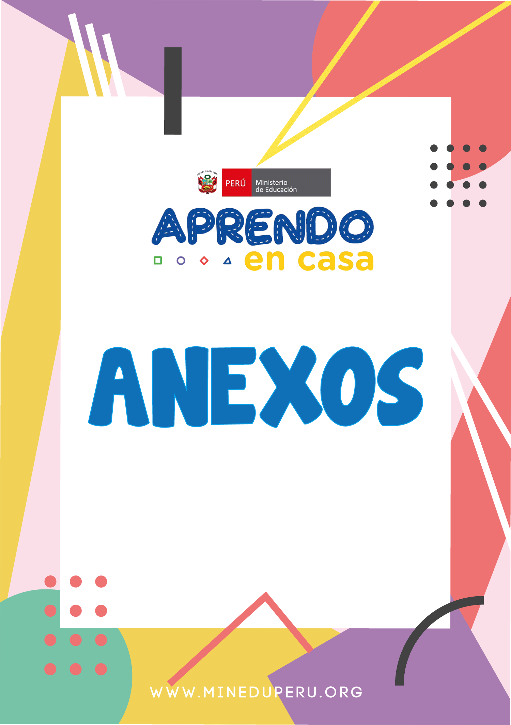

**FICHA DE INFORMACION DE FAMILIAS**



|  |  |  |  |  |  |  |  |
| --- | --- | --- | --- | --- | --- | --- | --- |
| **INSTITUCIÓN EDUCATIVA** | |  | | | **COD. MODULAR** |  | |
| **DOCENTE** |  | | **ÁREA:** |  | | **GRADO Y SECCIÓN:** |  |

|  |  |  |  |  |  |  |  |  |  |  |  |  |  |
| --- | --- | --- | --- | --- | --- | --- | --- | --- | --- | --- | --- | --- | --- |
| **N°** | **DATOS DEL ESTUDIANTE** | | **APODERADO**  Quién acompaña al estudiante | | **HOGAR (Priorizar un elemento electrónico para el uso del estudiante)** | | | | | | | | |
| N° CEL | Proveedor | Celular  Smartphone (SI/NO) | Cel.  Internet (SI/NO) | Correo Electrónico | PC/ Laptop/  Tablet (SI/NO) | Internet (SI/NO) | TV (SI/NO) | Radio (SI/NO) |
| **APELLIDOS Y NOMBRES** | **DNI** | **APELLIDOS Y NOMBRES** | **DNI** |
| 1 |  |  |  |  |  |  |  |  |  |  |  |  |  |
| 2 |  |  |  |  |  |  |  |  |  |  |  |  |  |
| 3 |  |  |  |  |  |  |  |  |  |  |  |  |  |
| 4 |  |  |  |  |  |  |  |  |  |  |  |  |  |
| 5 |  |  |  |  |  |  |  |  |  |  |  |  |  |
| 6 |  |  |  |  |  |  |  |  |  |  |  |  |  |
| 7 |  |  |  |  |  |  |  |  |  |  |  |  |  |
| 8 |  |  |  |  |  |  |  |  |  |  |  |  |  |
| 9 |  |  |  |  |  |  |  |  |  |  |  |  |  |
| 10 |  |  |  |  |  |  |  |  |  |  |  |  |  |
| 11 |  |  |  |  |  |  |  |  |  |  |  |  |  |
| 12 |  |  |  |  |  |  |  |  |  |  |  |  |  |
| 13 |  |  |  |  |  |  |  |  |  |  |  |  |  |
| 14 |  |  |  |  |  |  |  |  |  |  |  |  |  |
| 15 |  |  |  |  |  |  |  |  |  |  |  |  |  |
| 16 |  |  |  |  |  |  |  |  |  |  |  |  |  |
| 17 |  |  |  |  |  |  |  |  |  |  |  |  |  |
| 18 |  |  |  |  |  |  |  |  |  |  |  |  |  |
| 19 |  |  |  |  |  |  |  |  |  |  |  |  |  |
| 20 |  |  |  |  |  |  |  |  |  |  |  |  |  |
| 21 |  |  |  |  |  |  |  |  |  |  |  |  |  |
| 22 |  |  |  |  |  |  |  |  |  |  |  |  |  |
| 23 |  |  |  |  |  |  |  |  |  |  |  |  |  |
| 24 |  |  |  |  |  |  |  |  |  |  |  |  |  |
| 25 |  |  |  |  |  |  |  |  |  |  |  |  |  |
| 26 |  |  |  |  |  |  |  |  |  |  |  |  |  |
| 27 |  |  |  |  |  |  |  |  |  |  |  |  |  |
| **FICHA DE SEGUIMIENTO DE SESIONES "APRENDO EN CASA** | | | | | | | | | | | | | |



|  |  |  |  |  |  |  |  |  |  |  |
| --- | --- | --- | --- | --- | --- | --- | --- | --- | --- | --- |
| **DATOS** | INSTITUCIÓN EDUCATIVA | |  | | COD. MODULAR | |  | | N° SESIÓN |  |
| AREA |  | | COMPETENCIA(S) | |  | | | | |
| NOMBRE DE LA SESIÓN | |  | | CICLO |  | GRADO |  | SECCIÓN |  |
| DATOS DEL DOCENTE | |  | | | | FECHA | |  | |

|  |  |  |  |  |  |  |  |  |  |  |  |  |  |  |
| --- | --- | --- | --- | --- | --- | --- | --- | --- | --- | --- | --- | --- | --- | --- |
| DESARROLLO DE LA SESIÓN | | | | | | | | OTRAS ACCIONES REALIZADAS POR EL DOCENTE (OPCIONAL) | | | | | | |
| N° | NOMBRE(S)  DEL  ESTUDIANTE | APELLIDOS DEL ESTUDIANTE | Participó de la sesión (SI/NO) | Medio por el cual se  conectó | | | ¿Se dejó  actividades a  través de la | Se le dejó  actividades al  estudiante | Recurso  educativo  utilizado | El docente  generó  reuniones con | Si se reunió,  especificar el  medio (Cel., | Fecha | Tema tratadO | Observaciones |
| Pág. web | TV | Radio |
| 1 |  |  |  |  |  |  |  |  |  |  |  |  |  |  |
| 2 |  |  |  |  |  |  |  |  |  |  |  |  |  |  |
| 3 |  |  |  |  |  |  |  |  |  |  |  |  |  |  |
| 4 |  |  |  |  |  |  |  |  |  |  |  |  |  |  |
| 5 |  |  |  |  |  |  |  |  |  |  |  |  |  |  |
| 6 |  |  |  |  |  |  |  |  |  |  |  |  |  |  |
| 7 |  |  |  |  |  |  |  |  |  |  |  |  |  |  |
| 8 |  |  |  |  |  |  |  |  |  |  |  |  |  |  |
| 9 |  |  |  |  |  |  |  |  |  |  |  |  |  |  |
| 10 |  |  |  |  |  |  |  |  |  |  |  |  |  |  |
| 11 |  |  |  |  |  |  |  |  |  |  |  |  |  |  |
| 12 |  |  |  |  |  |  |  |  |  |  |  |  |  |  |
| 13 |  |  |  |  |  |  |  |  |  |  |  |  |  |  |
| 14 |  |  |  |  |  |  |  |  |  |  |  |  |  |  |
| 15 |  |  |  |  |  |  |  |  |  |  |  |  |  |  |
| 16 |  |  |  |  |  |  |  |  |  |  |  |  |  |  |
| 17 |  |  |  |  |  |  |  |  |  |  |  |  |  |  |
| 18 |  |  |  |  |  |  |  |  |  |  |  |  |  |  |
| 19 |  |  |  |  |  |  |  |  |  |  |  |  |  |  |
| 20 |  |  |  |  |  |  |  |  |  |  |  |  |  |  |
| 21 |  |  |  |  |  |  |  |  |  |  |  |  |  |  |
| 22 |  |  |  |  |  |  |  |  |  |  |  |  |  |  |
| 23 |  |  |  |  |  |  |  |  |  |  |  |  |  |  |
| 24 |  |  |  |  |  |  |  |  |  |  |  |  |  |  |
| 25 |  |  |  |  |  |  |  |  |  |  |  |  |  |  |

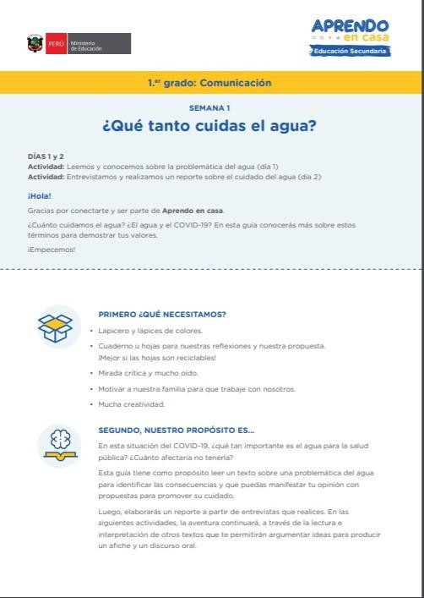

S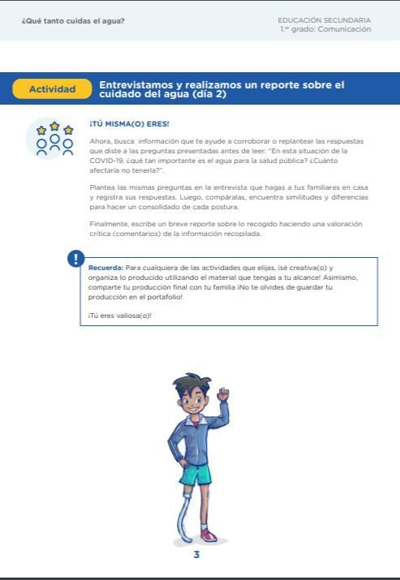

Apellidos y Nombres [Docente]



Grupo de Facebook:

<https://www.facebook.com/groups/560320491000136/>

Fans Page Facebook:

<https://www.facebook.com/Ministerio-Educaci%C3%B3n-100150368371743/>

Canal de Youtube:

<https://www.youtube.com/channel/UCpxfK24vb7_L7Hf20ZuvFSw>